**MENTAL HEALTH**

**SUPPORT**

**ABSTRACT:**

This application aims to address the pressing need for accessible and effective mental health support in today's fast-paced world. Recognizing the increasing prevalence of mental health challenges, our solution leverages advanced technology to provide users with a comprehensive and user-friendly platform for mental well-being.

The application integrates evidence-based therapeutic approaches, such as Cognitive Behavioural Therapy (CBT) and mindfulness techniques, into an interactive and personalized user experience. Through a user-friendly interface, individuals can access a variety of self-help resources, guided exercises, and educational content tailored to their specific needs.

**SOFTWARE REQUIREMENTS:**

* Html, CSS, JavaScript
* MySQL
* Java

**Data Flow Diagram :**

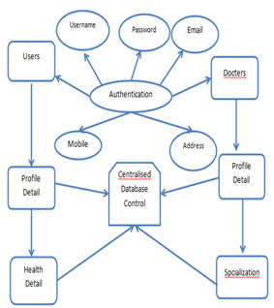

**CONCLUSION:**

In conclusion, the proposed mental health support application represents a pioneering approach to addressing the escalating global mental health crisis. By combining innovative technologies with evidence-based therapeutic strategies, this project aspires to offer a holistic and user-centric solution for individuals seeking mental well-being support. The integration of personalized well-being plans, virtual support groups, mood tracking, and professional guidance aims to create a versatile platform that adapts to users' unique needs and preferences.

The commitment to user privacy and confidentiality, as evidenced by robust security measures, underscores the project's dedication to creating a safe space for individuals to explore and enhance their mental health. The incorporation of a responsive chatbot and seamless teletherapy options further ensures immediate access to emotional support and professional counselling. As the world continues to recognize the importance of mental health, this application stands as a beacon of innovation, compassion, and support for those on their journey towards a healthier and more fulfilling life.

**REFERENCES :**

<https://www.w3schools.com/html>

<https://www.w3.org/style/css>

<https://wikepedia.or/wiki/MySQL>

<https://wikipedia.org/wiki/javascript>

<https://httpd.apache.org>

Learning MySQL & JavaScript: With j Query, CSS & HTML

Java: The Complete Reference: Herbert   Schildt